Escanaba Sex Offender Registry

Click below for the list of Escanaba Sex Offenders

Click below for Sex Offender Map Zone
Right Click to open Hyperlink

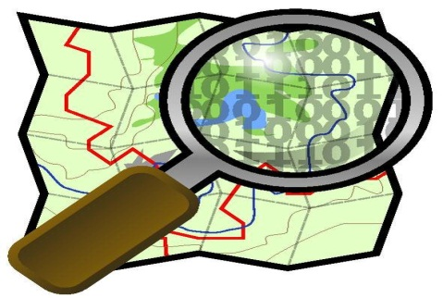

Sex Offender 500 foot Probation/Parole SOR Park Zone

Sex Offender 1,000 foot Restricted School Zone

